SIT120 - Introduction to Responsive Web Apps Week 1: Introduction to HTML, CSS

**List of Tasks:  
Pass Task 1 – Create an HTML Page**

Learning reflections:

HTML is a markup language which is used to create web pages. It stands for HyperText Markup Language. There are different html elements which have different attribute properties to describe and structure the web page contents.

Below is the screenshot of simple web page & html code.

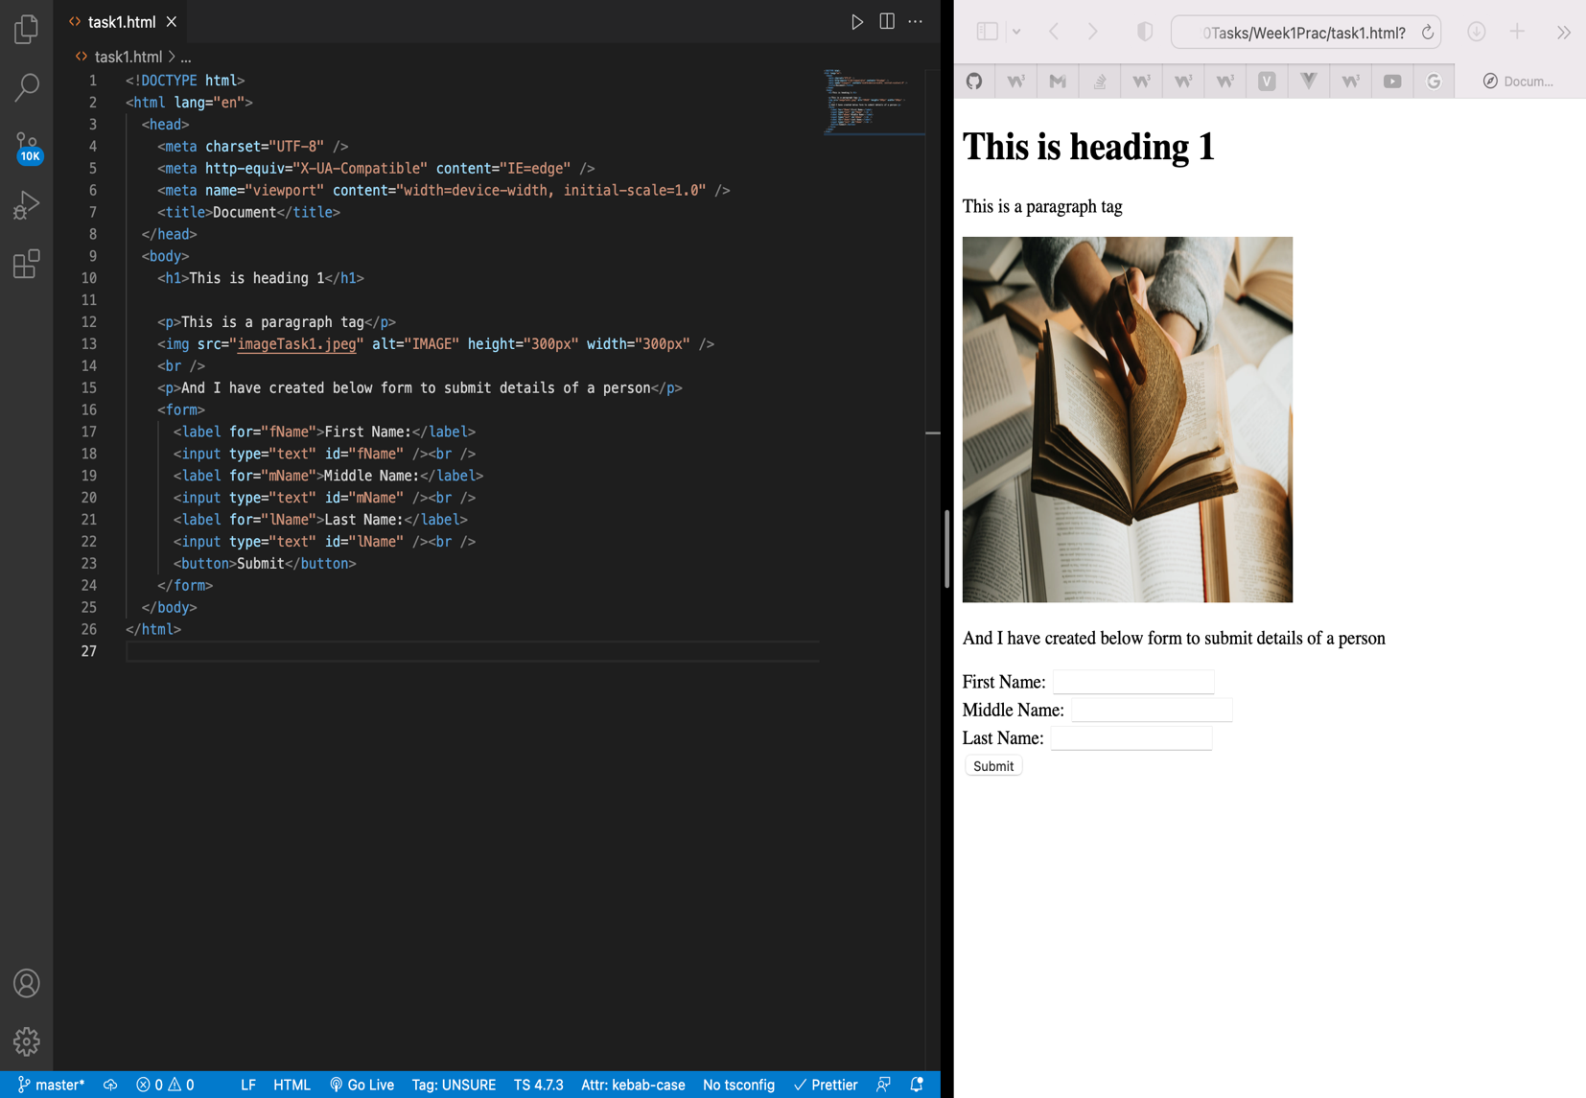

**Pass Task 2 – Add CSS to your HTML page**

CSS stands for Cascading Style Sheets which is used to decorate webpages. There three different ways to add css properties in html elements.

1. Inline
2. Internal
3. External

Below is a web page after implementation of CSS styling.

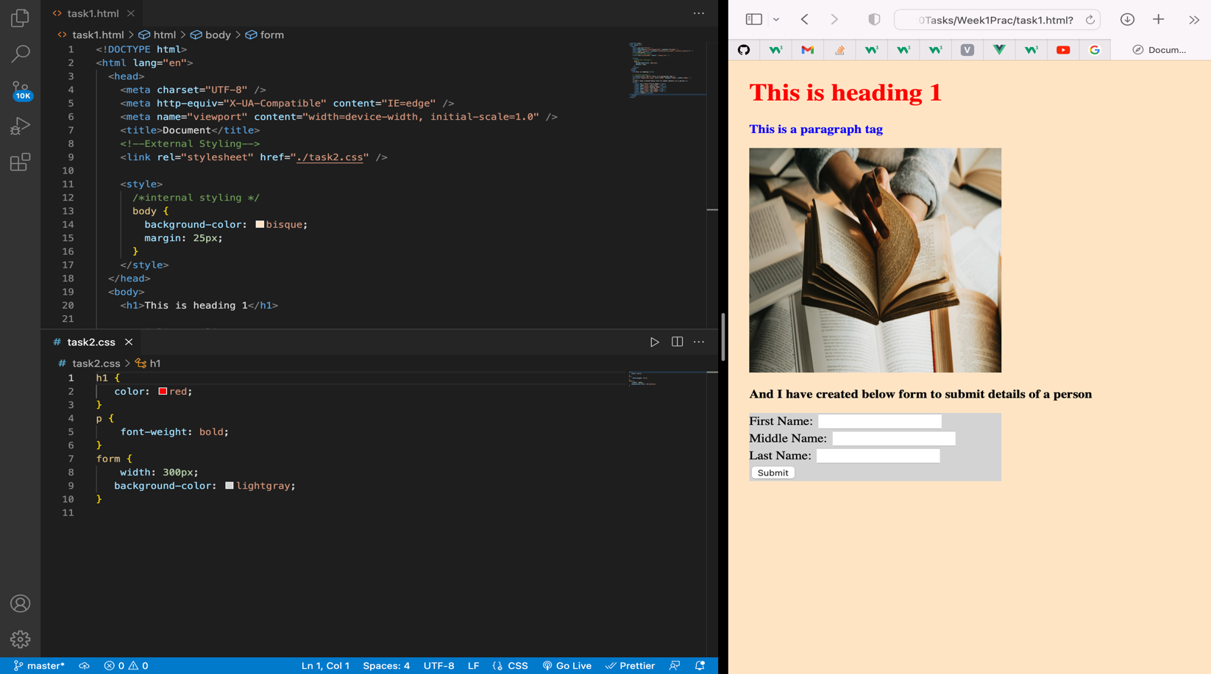

**Pass Task 3 – Adding JavaScript**

JavaScript is a scripting language that adds functionality to the html elements and makes the webpage responsive with the users.

Below webpage shows that if a user clicks the button “Current Date & Time” it displays current date & time

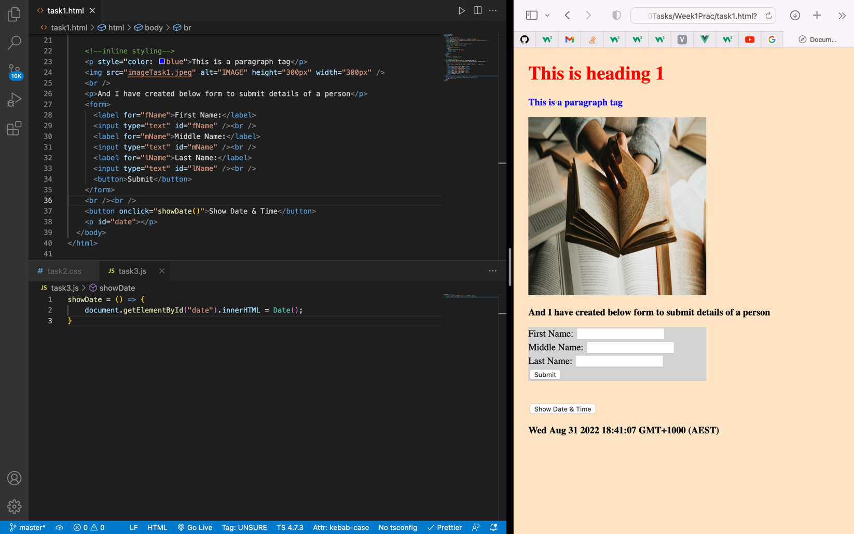

**Pass Task 4 – How to use Git and GitHub**

To use GitHub, we must create an account. Once the account is created, we can create a repository where we can add our project files and share it with other users to collaborate in the project.

Below is the screenshot of the page after a repository is created.

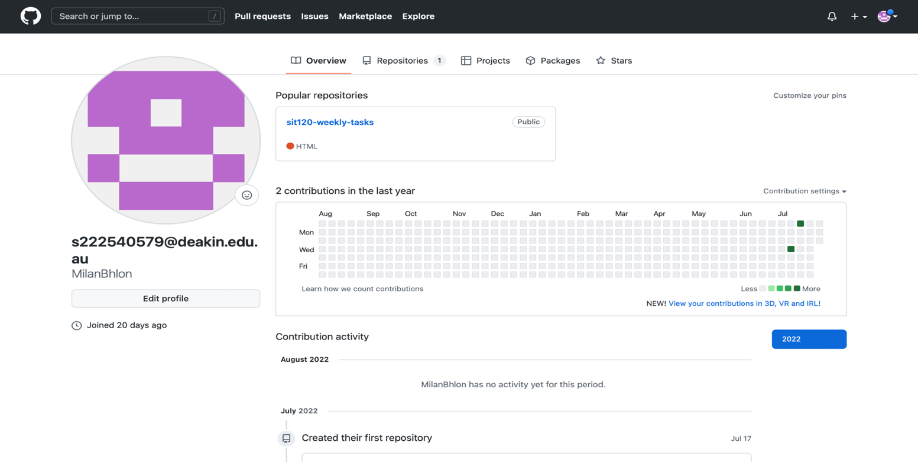

**Credit Task 5 – Vue.js Framework (homework)**

Vue is a JavaScript framework for building user interfaces. It builds on top of standard HTML, CSS and JavaScript, and provides a declarative and component-based programming model that helps you efficiently develop user interfaces, be it simple or complex.

Below is a simple vue todo app.

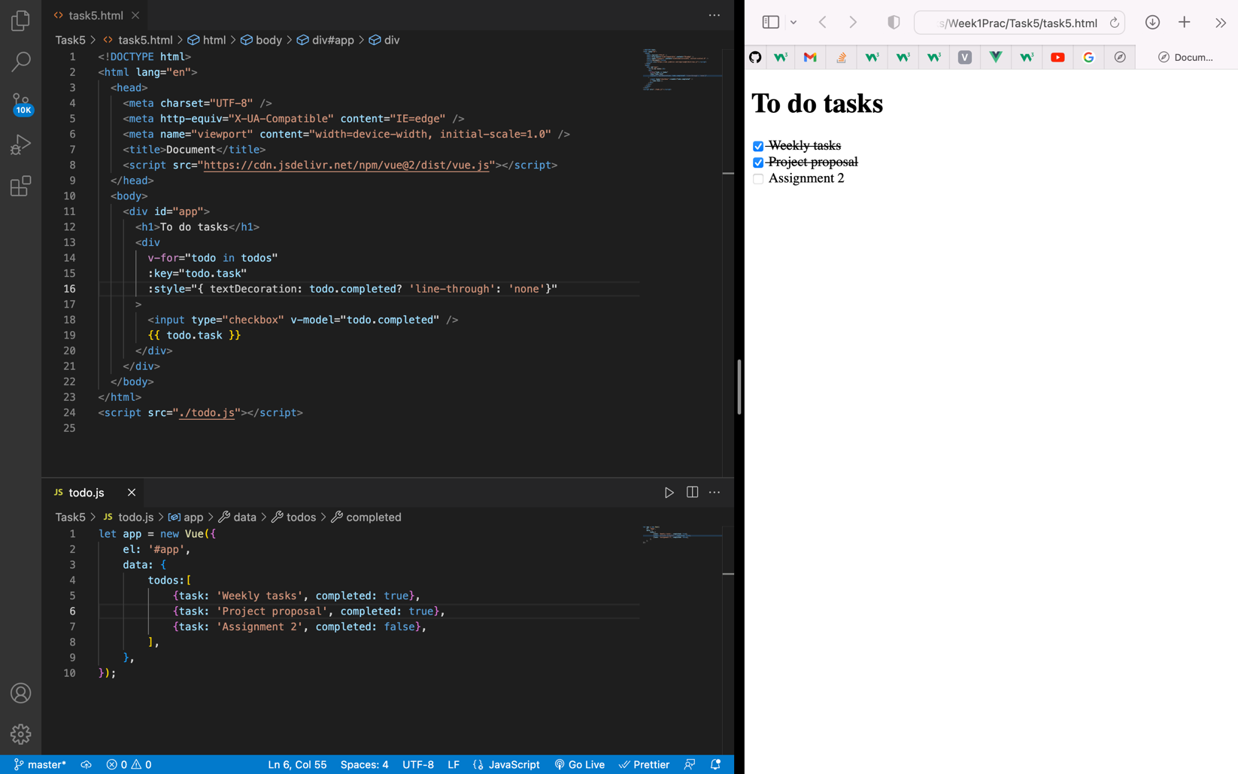

SIT120 – WEEK 2

**Overview:**

Learning Reflections:

This week we learned the concept of responsive web design which helps to design a website to display the contents in mobile devices without compromising its quality. This can be achieved by considering different factors such as screen size, device type etc.

**List of Tasks:  
Pass Task 1 – Understand about responsive web Pages and apps**

* Responsive web design is a way of designing web pages in such a way where it responds to user needs depending on the devices they’re using. Responsive web pages change the layout based on the size & capabilities of the device. For example, on an iPhone, users would see content shown in a single column view; a tablet might show the same content in two columns.

Responsive web design is important because it helps us to design sites which can adapt to different mobile devices which are often constrained by display size & additional features today or in future for users’ better experience.

As you can see in the below images that the site is responsive to different devices as per their display size.

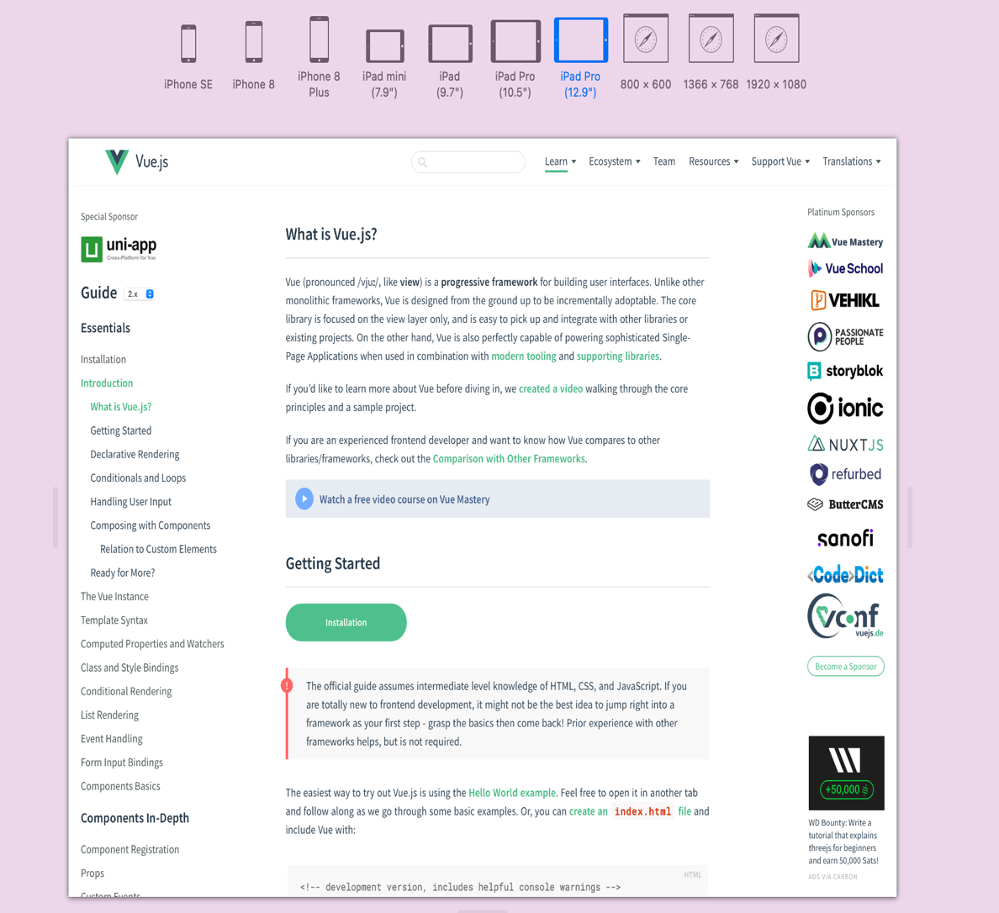

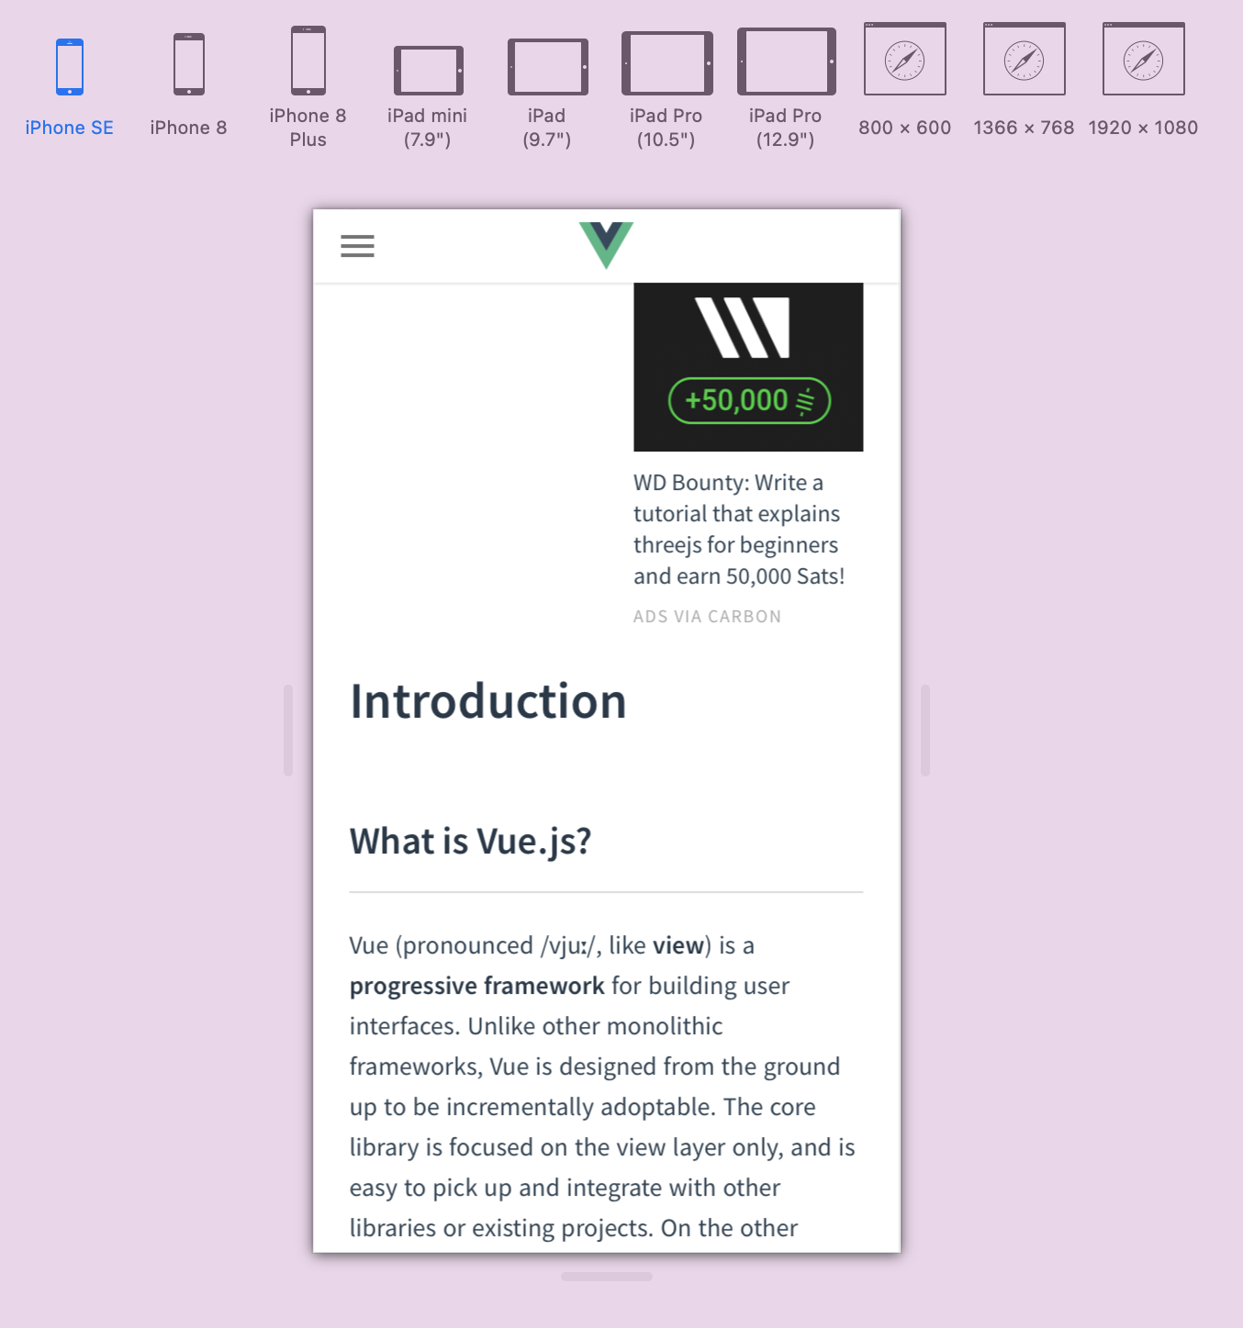

**Pass Task 2 – Understanding how responsive web design can be implemented using CSS Instruction:**

**CSS media queries for responsive web design implementation**

Sometimes more extensive changes are needed to support layout in different screen sizes. Media queries become useful in this kind of scenario.

Media queries are simple filters that can be applied to CSS styles which make it easy to change styles based on the types of devices rendering the content, or the features of that device. For example, width, height, orientation, ability to hover, and whether the device is being used as a touchscreen.

**Screenshots**

Below screenshots shows how @medai rule can be implemented. It shows that when the device screen maximum width is <=600px, the background colour changes to light-blue and when the device screen width is >600px, the background colour changes to yellow.

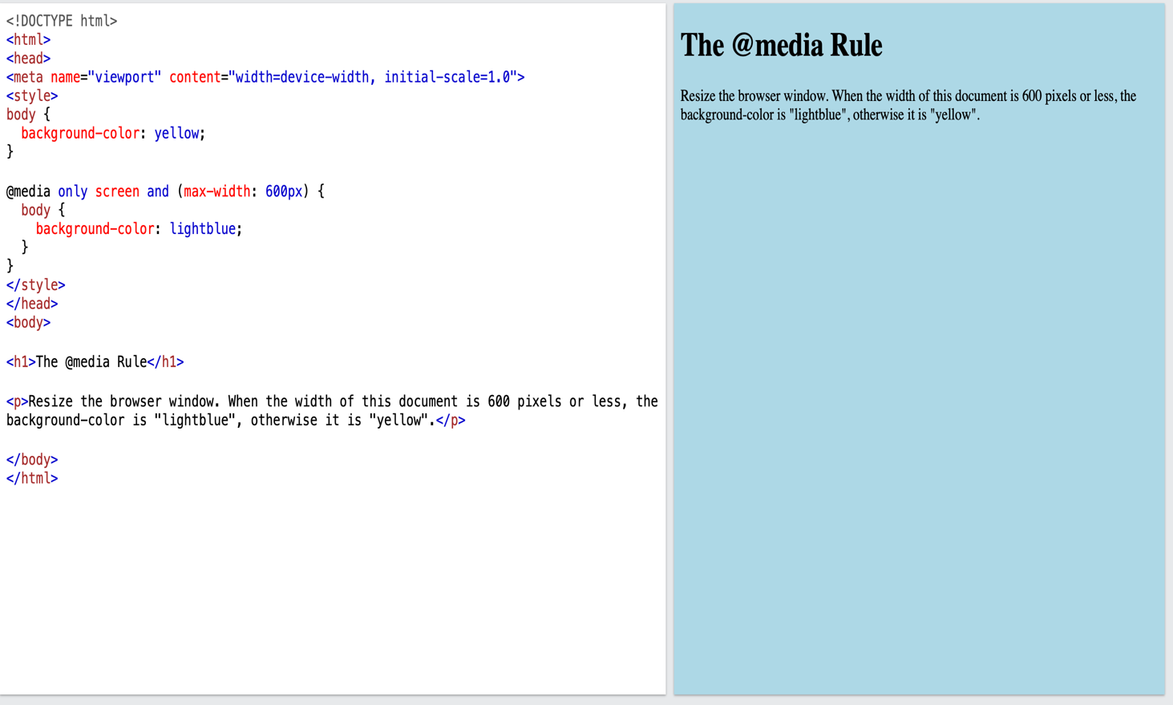

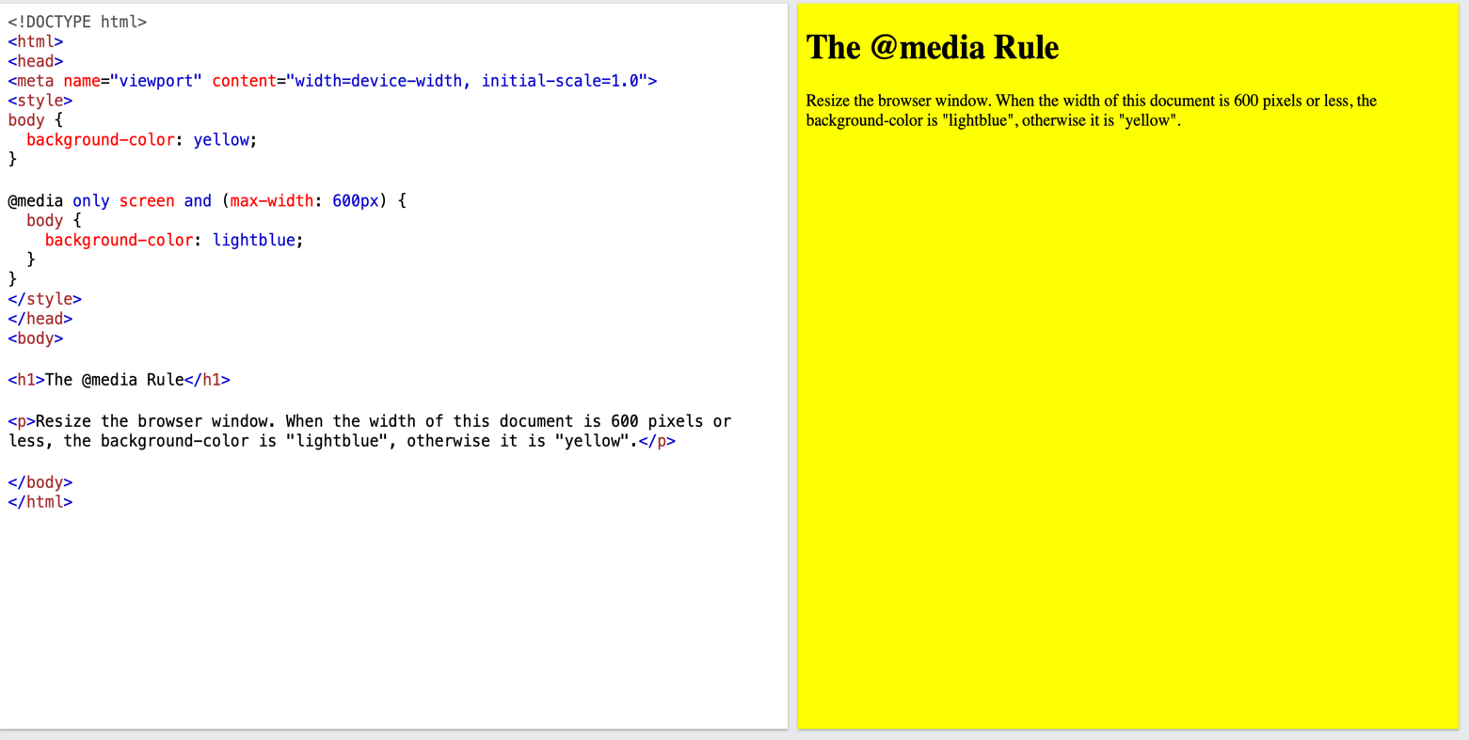

**Credit Task 3 – User stories and UI/UX design for your project**

* User stories are important because it helps to clarify the software functionality which make the development process easier. Similarly, UI/UX protype helps to demonstrate user stories in an effective graphical manner and helps to figure out any challenges before starting the UI tasks.

**User Stories:**

1. **As a member, I want to create either a public or private profile**
   1. Members should be able to enter their personal details
   2. Verify the details & complete the signup process
   3. Once the member is logged into their profile, there should be an option to make the profile public or private
   4. Member should be able to update more details about their health & fitness once they are logged in to maintain proper track record of their fitness journey
   5. There should be an option to upload profile picture
   6. There should be an option to upload recent & past pictures of the member is fitness gallery to create a visual track record
2. **As a member, I want to update my profile**
   1. Member should be able to update their profile in profile setting page
   2. Should be able to change profile picture
   3. Should be able to add or delete pictures from the fitness gallery
   4. Should be able to change their profile type either from private to public mode or vice-versa
   5. They should be able to update their new or change old details

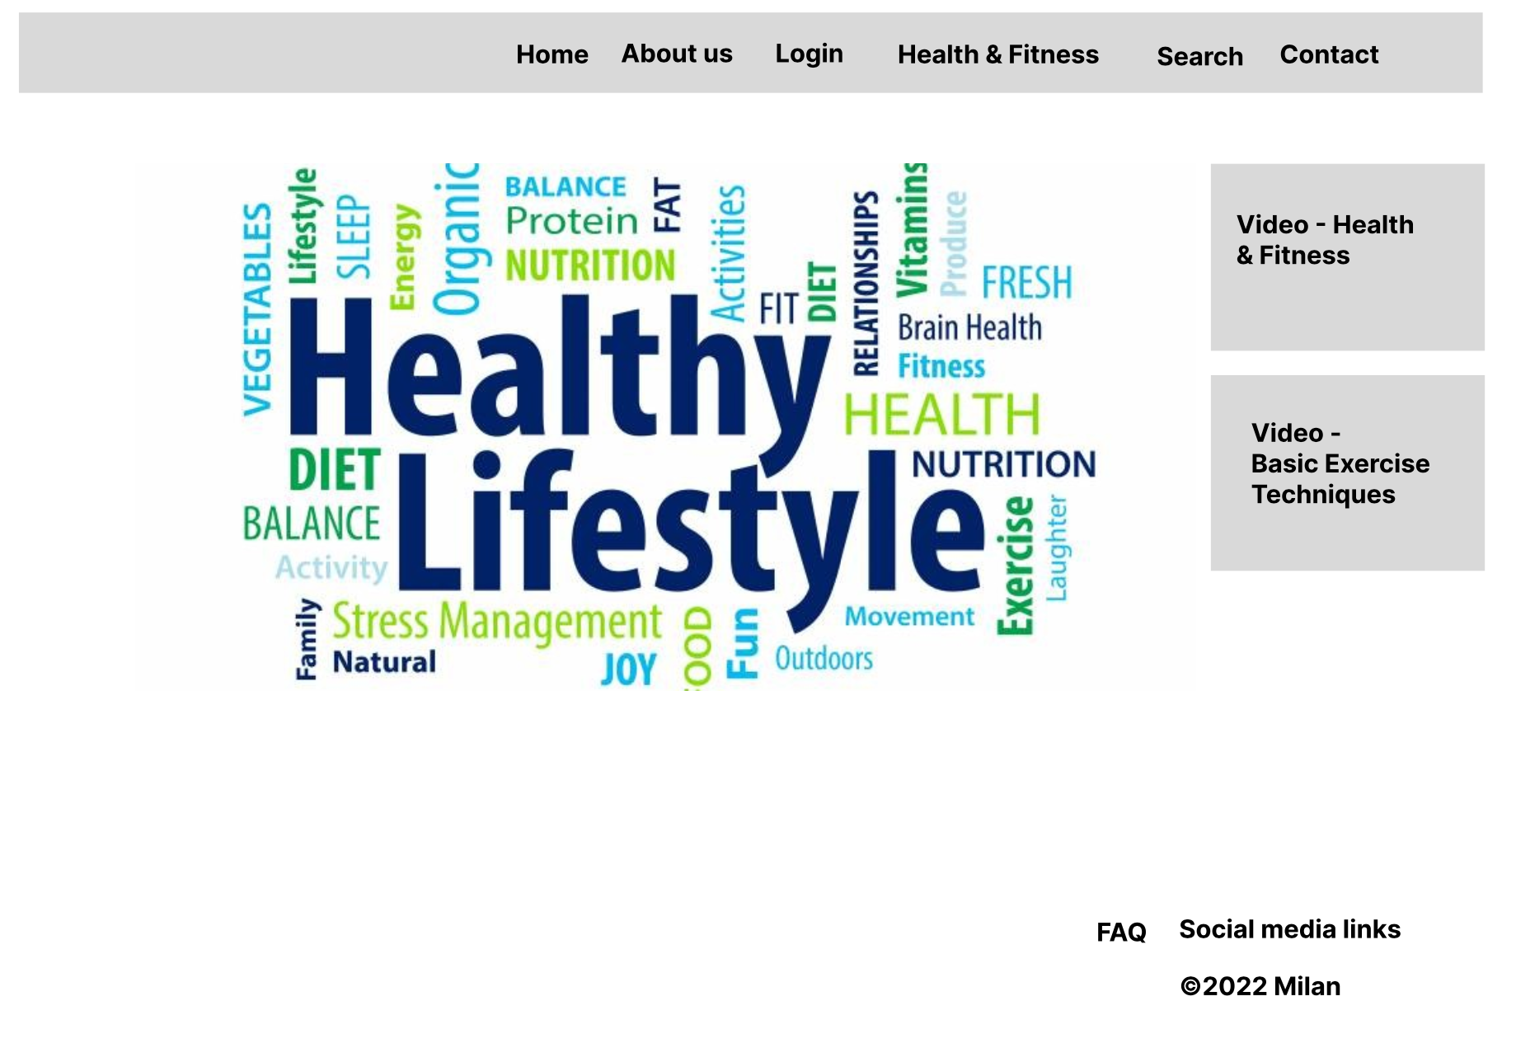Below 3 images are the UX/UI design for my project

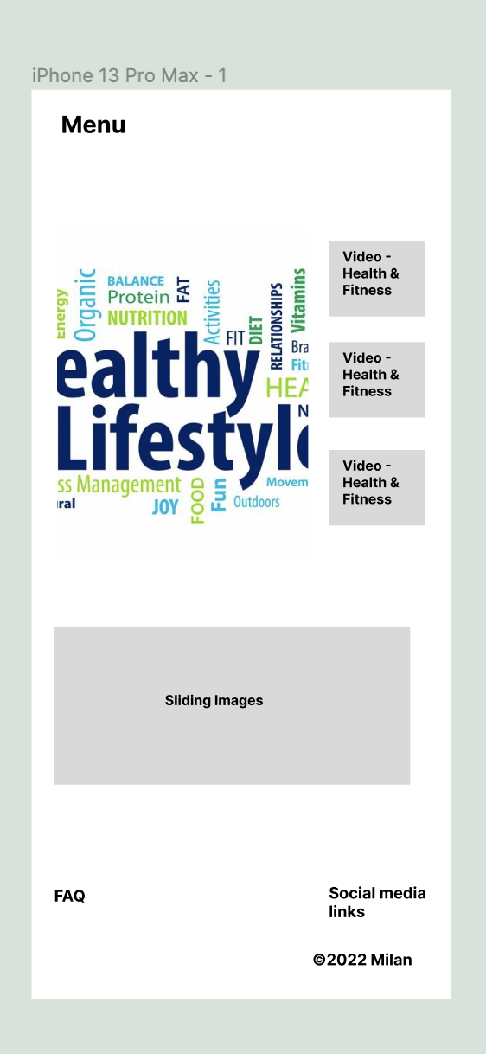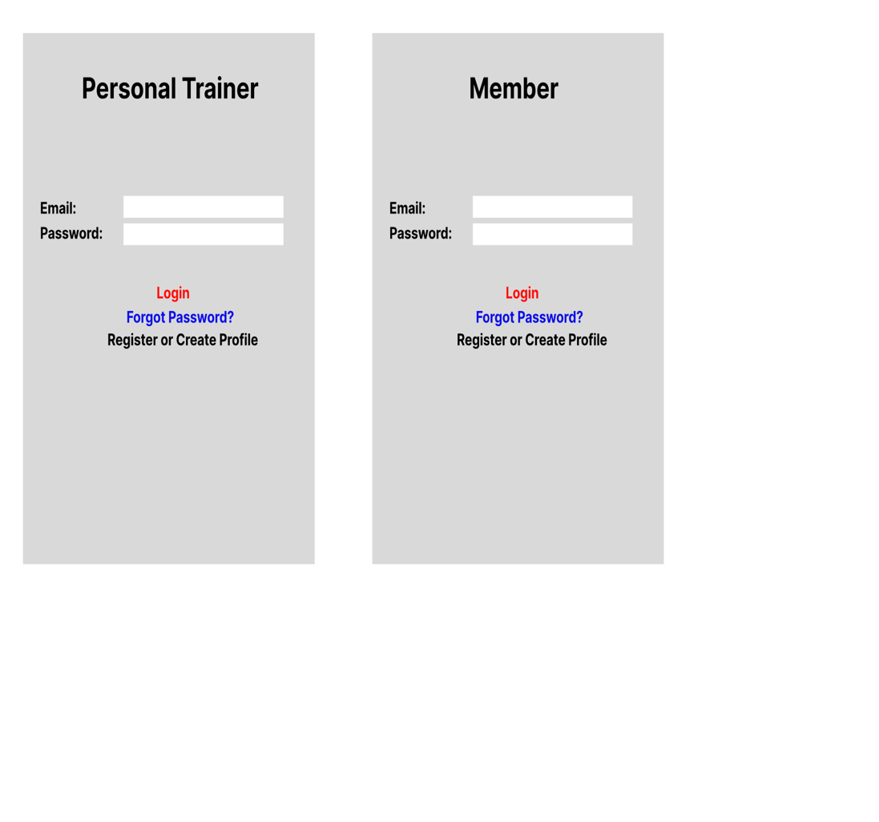

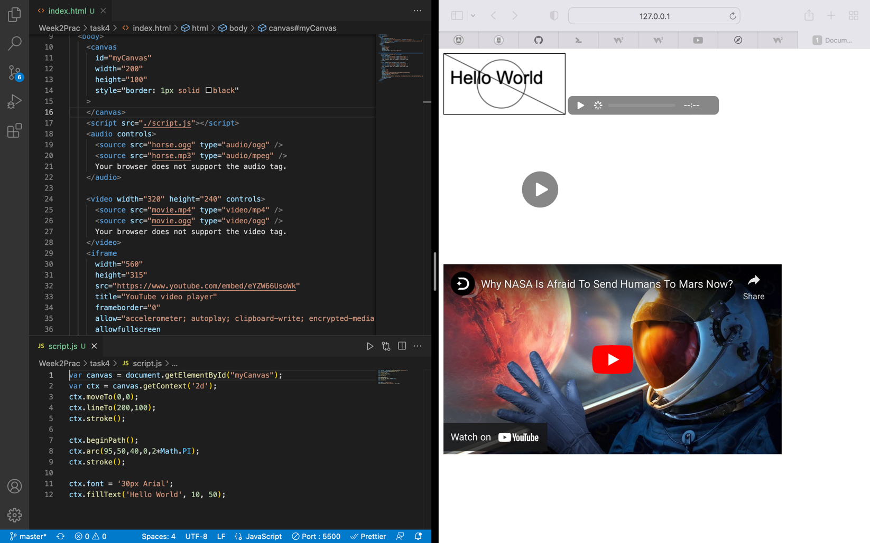**Distinction Task 4 – Use graphics, media and APIs (Homework)**

